Contents

1) Introduction 1

2) Building combination forms 3

# Introduction

Combination form, as the word implies is a combination of various forms which can be created in the ZHOpenemr. Forms for increased productivity are one of the great advantages of an EMR. It is a constant work in progress and will continue to evolve as the needs of your practice evolve. Forms can be specific for a practice, for an individual provider, for an individual organization that requests information, and for any other entity that interfaces with the system.

As users become accustomed to using an electronic interface, they can identify repetitive steps or repetitive communications that could be incorporated into a form. Forms enable rapid data entry of variables and automatic data entry of demographics, diagnoses, insurance plans, and other needed information

These forms can be of various types. for example:

* Family History
* Past Medical History
* History of Present Illness

There would be various other types of forms that can be created based on doctors area of practice.

This document guides the user on how to create a set of forms or **combination forms** in ZHOpenemr. Once we’ve logged in to the ZHOpenemr, go to Administration >> then ZH Globals

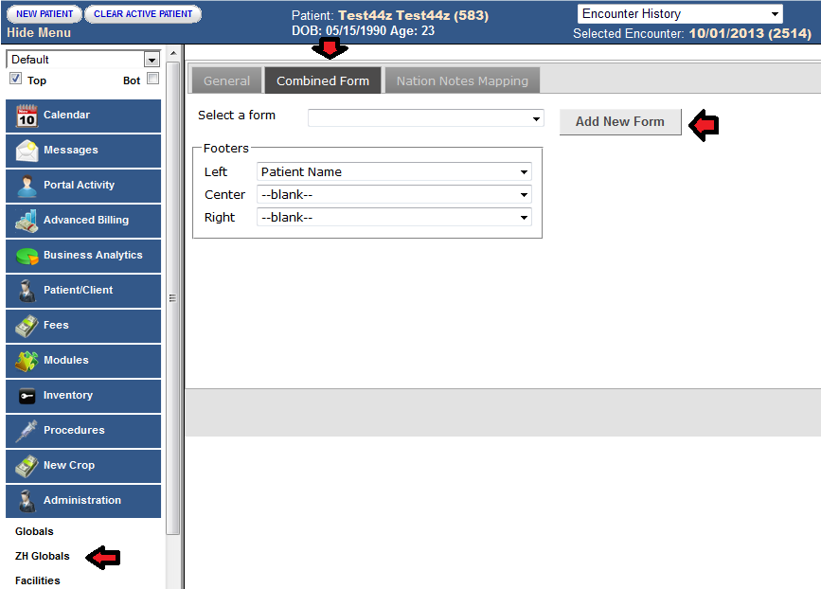

This screen takes us to the page where the users are able to control the settings of the combination form and also enables to build the form for the user.

# Building combination forms

To build a form click on **Combined Form.**

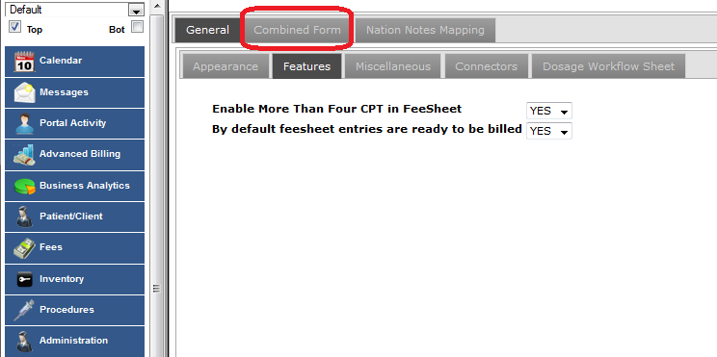

**General** tab helps the user to go through all the setting for the combination form

* **Appearance** :

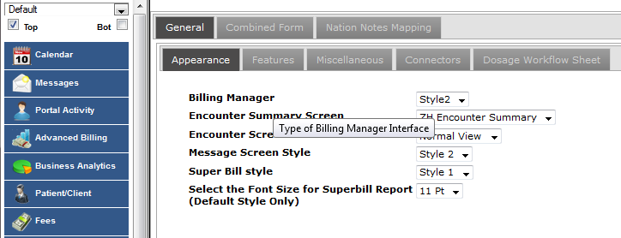

This setting enable the user to change the appearance of the billing manager, encounter summary screen, encounter screen, message screen style, super bill style and select the font size for the superbill report.

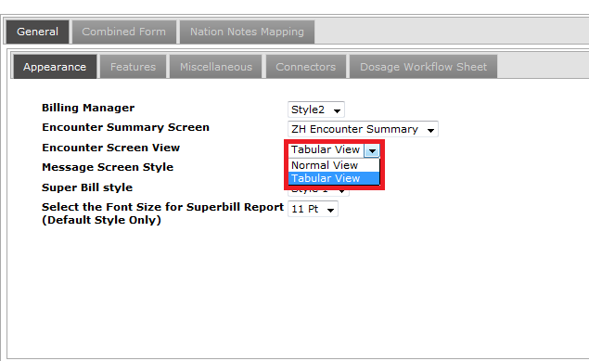

Combination form provides two type of encounter screen view.

* Normal View
* Tabular View

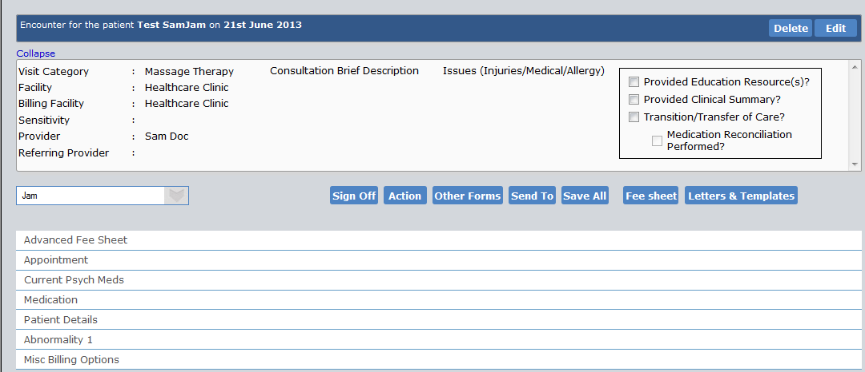

The above image shows you tabular view of the **Encounter Screen.**

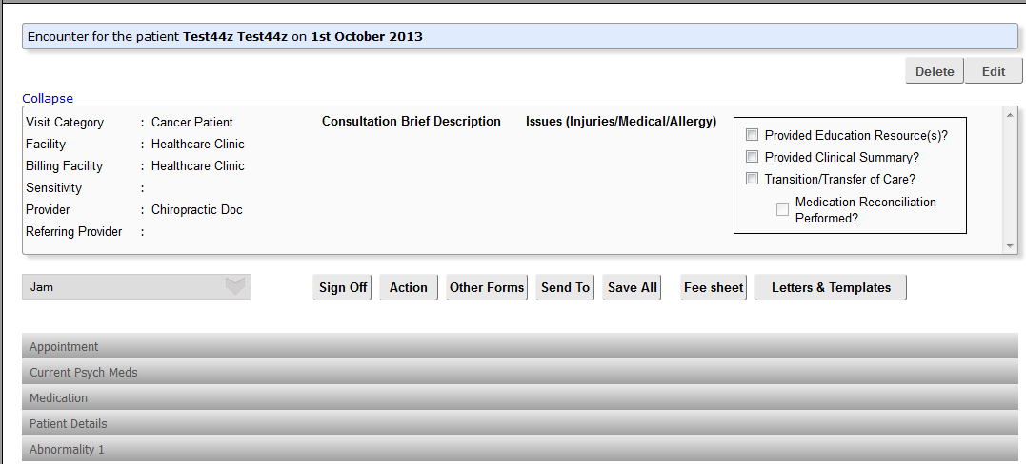

The above screen shows normal view of the **Encounter Screen.**

* **Features**:

This tab in the Combination form provides the user two important features

* Enabling the user to enter more than four CPT in the FeeSheet.
* By default Feesheet entries can be billed.

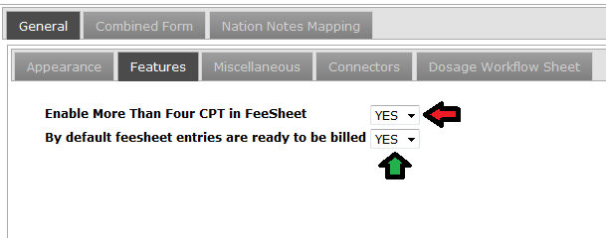

Clicking on the **Add New Form** button takes us to the following page.

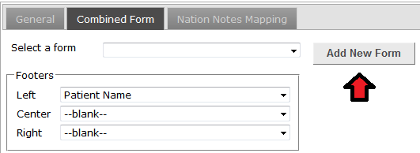

Enter the desired Combination Form Name in the text box provided along with the Facility and the provider under which the forms are to be created.

We have created a combination form called **Test1.**

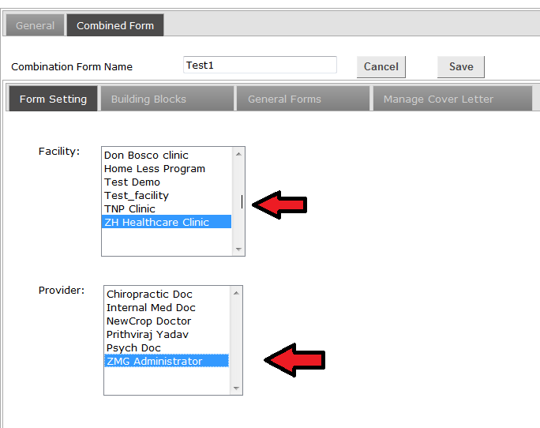

Currently we have added **ZH Healthcare Clinic** as the facility and **ZMG Administrator** as the provider.

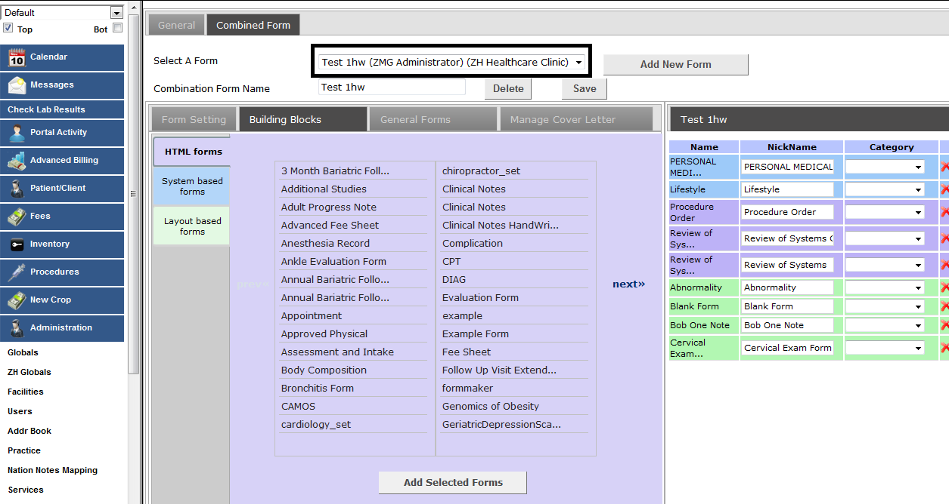

Once we select the combined form **TEST1hw**,the user will have the option to select any number forms which is already created in the ZHOpenemr such as HTML forms, System based forms, Layout based forms.

* HTML Forms: These forms have special features and are created as per the provider’s requirement based on the field of practice and personal interest.
* System based forms: these are the basic forms like Personal Medical History, Insurance, Demographics, and Social History etc.
* Layout based forms: Built in functionality to create forms within open EMR.

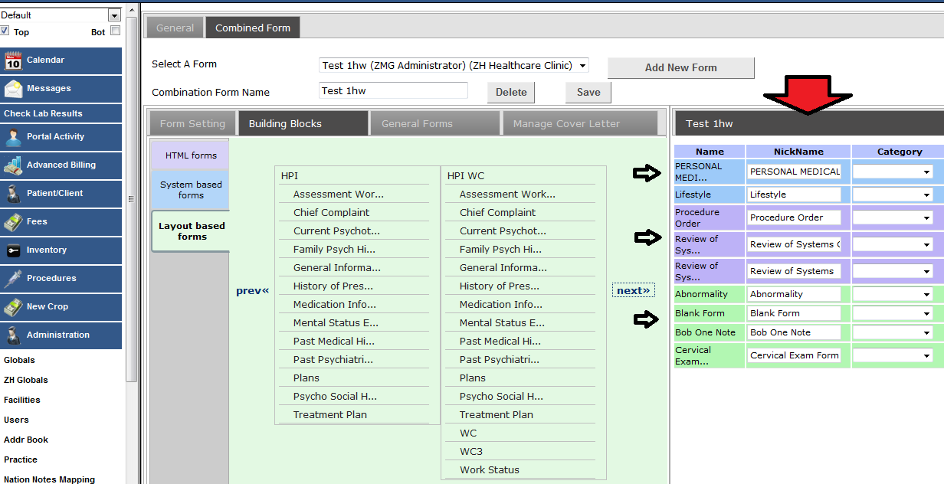

With each building block having a number of forms, these can be added by double clicking with the help of your mouse on the forms to be added to the **Test1hw**.

The forms which is used to create a combination form is being added up in the right side of the table so that the user can have a better look at the selected forms

(Note: combination form name can be changed at any point of time just by making the change in the text box provided in Combination Form Name and click save.)

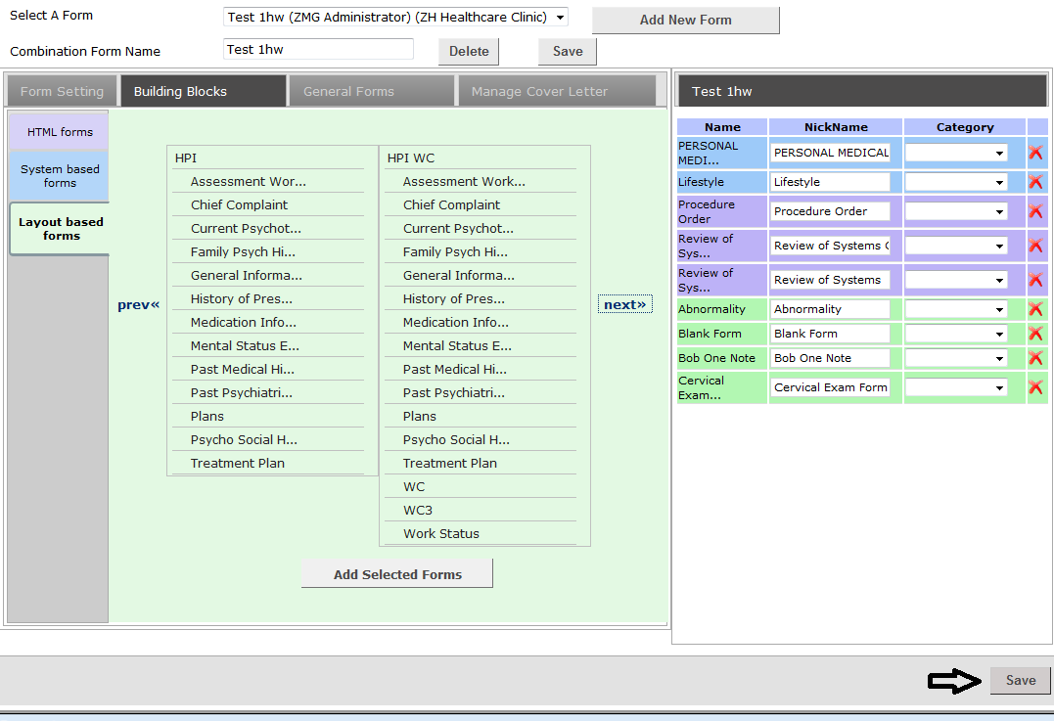

Click the **Save** button after the forms has been finalized and ready to be shown up with the respective **provider** and **facility.**

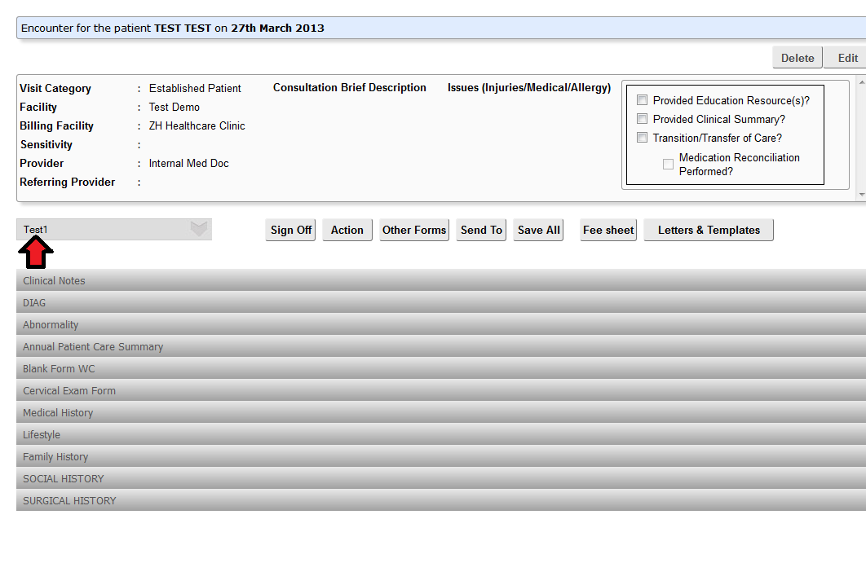

After clicking the save button, select an encounter which has the same provider and facility as that of the form which was created by the user.

Finally the user will be able to view the form which was created in ZH Encounter Summary.

Once the front office/nurse/doctor enters the necessary information in the combine forms,it is saved and have the option to convert it to either PDF or take a print out.

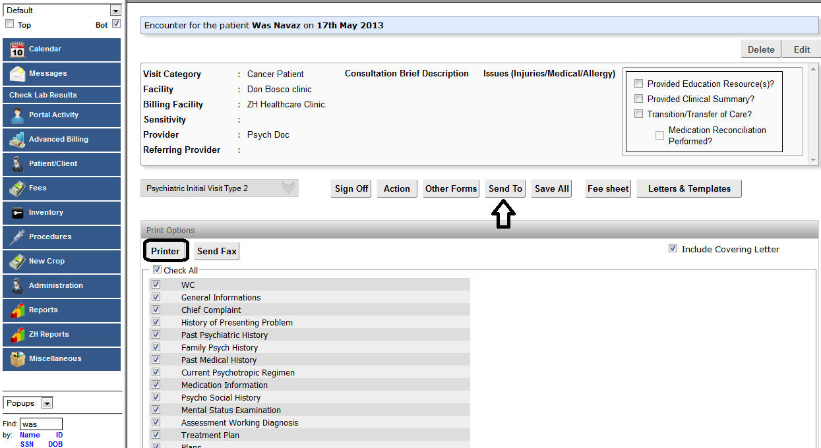

To take a print click Send To >> Printer.

(note: user have the option to take a print of any particular form by selecting or option to select every form by selecting **Check All)**

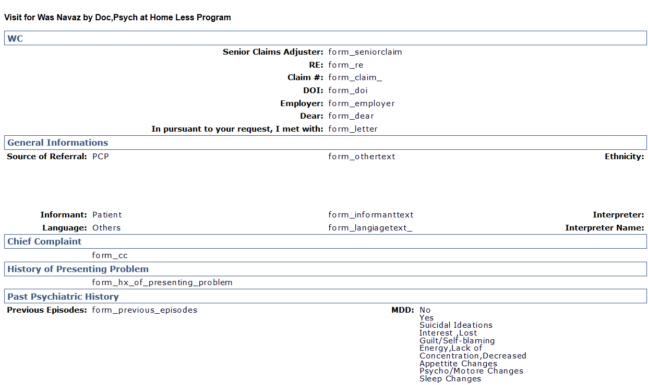

This is a preview of the print out page